
Stage 1 - Semester 2
May 2023
COMP18025 Networking

Internal Examiner(s): Paula Duffy

External Examiner(s): xxxxxxx

Date:
Time:
Duration:
Venue:
No. Pages: 4

Instructions
Answer Any 4 Questions. Each question is worth 25 marks.Total marks on paper is 100.

PLEASE NOTE: Exam Paper printed DOUBLE SIDED.
DO NOT TURN THIS PAGE UNTIL INSTRUCTED

Question 1.

- Differentiate between Bandwidth and Throughput in networks.
(4 marks)
- In terms of networking media, what is noise?
(2 marks)
- Compare and Contrast Fibre Optic and Twisted Pair cabling. Your answer should include the characteristics of each, advantages and disadvantages. Discuss their approaches to noise prevention. Include relevant diagrams.
- marks)
- Discuss Structured Cabling as implemented in DKIT.

(5 marks)
Question 2.

- What is the purpose of the OSI model? In your answer briefly explain its layers and structure.
- marks)
- Outline the layers of the TCP/IP reference model. Explain what encapsulation refers to and identify the PDUs [Protocol Data Units] used at each layer.
- marks)
(c) A DNS request has been issued from a PC over an ethernet network using UDP. Draw the encapsulated packet.
(4 marks)

Question 3

  - What is a MAC address? Explain how MAC addresses are used in Ethernet networks.
(2 marks)
  - Draw the Ethernet II frame. Clearly show the size of each field within the frame.
(7 marks)
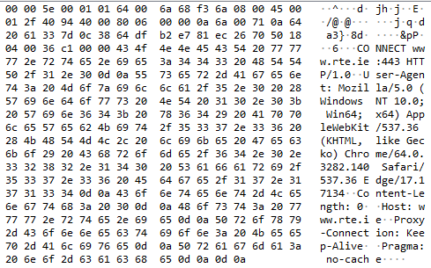
Figure 1 Wireshark Dump

  - Examine the hex data shown in Figure 1. This is a HTTP request for the web page www.rte.ie. Decode the Ethernet frame and answer the following:-
    - Which address is the frame being sent to? Is this address a Unicast, Broadcast or Multicast?
(2 marks)
    - Which address sent it? Is this address a Unicast, Broadcast or Multicast?
(2 marks)
    - What is the next upper layer protocol? Describe in detail the function of this protocol.
(6 marks)
  - If the polynomial generator is , calculate the CRC for the data element 11100101.
(6 marks)

Question 4.

- Two devices used to extend a LAN are Hubs and Switches. Describe the features of both explaining how they operate and their associated OSI layer.
(6 marks)
- Examine the network in Figure 1. What kind of topology is being used in the network?
(1 marks)
- Consider the following campus network connecting three access layer (layer 2) switches (Switch X, Switch Y and Switch Z) connecting host clients (A, B, C, D, E and F) with a Web Server (WS) and File Server (FS) in Figure 1. Assume no VLANS have been configured on this network.
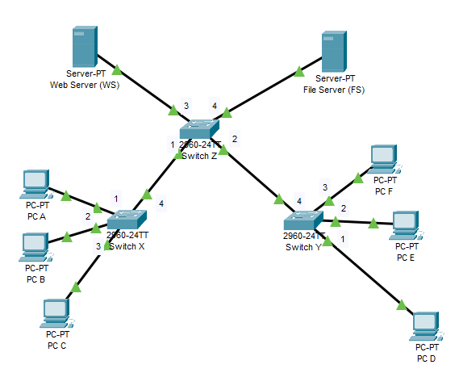
Figure 1 Network Diagram

Question 4c continued on next page

Question 4c continued

Using Table 1 below as a guide, update the Mac-Address tables on each of the switches after the following communications. Assume ARP caches are populated, and MAC Address tables are empty in this instance:

- After A sends a web request to the Web Server (WS).
- After the Web Server (WS) replies to A.
- After F sends a web request to the Web Server (WS).
- After the Web Server (WS) replies to F.
- After C sends a web request to the File Server (FS).
- After the File Server (FS) replies to C.
- After E sends a web request to the File Server (FS).
- After the File Server (FS) replies to E.

Scenario | Switch X |  | Switch Y |  | Switch Z
Scenario | MAC (device) | Port | MAC (device) | Port | MAC (device) | Port
- 3
- 4
- 6
- 7
- 8
Table 1 Mac-Address Tables for each switch
- marks)
- What is a VLAN? Discuss 3 reasons to include VLANs in your network design.
(10 marks)

Question 5.

- Indicate the role of a carrier signal in analogue transmission.
(4 marks)
- Indicate which characteristics of an analog signal are changed to represent the digital signal in each of the following digital-to-analog conversion?
  - ASK
  - FSK
  - PSK
  - QAM
(4 marks)
(c) Explain why synchronisation is important in data communications.
(5 marks)

(d) Draw a graph of the data stream 1110101, assuming that the last signal level has been positive, for the following encoding schemes: -
  - NRZ – I
  - Manchester Encoding
(12 marks)

